CREDIT CARD FRAUD DETECTION USING MACHINE LEARNING

Abstract
Credit card fraud detection has become increasingly critical with the rise in digital payment methods.This study compares the performance of machine learning models—XGBoost, Random Forest, SVM, —for identifying fraudulent transactions. Data Preprocessing steps involved removing irrelevant features, addressing outliers, and splitting the data into training (80%) and testing (20%) sets. Performance metrics such as precision, recall, accuracy, F1 score, and confusion matrix were used to evaluate each model's effectiveness.These advanced models demonstrated the potential of machine learning to adapt to evolving fraudulent patterns, providing scalable and reliable fraud detection.The importance of advanced machine learning techniques in combating fraud, emphasizing the trade-offs between accuracy, scalability, and computational efficiency.

KEYWORDS Credit Card Fraud Detection , Machine Learning Models, XGBoost,
Fraudulent Transactions

INTRODUCTION

Credit cards are one of the most commonly used payment methods in today’s world, with the rising popularity of credit cards, frauds in them are increasing as well. Credit cards play a vital role in today's commerce, providing ease and versatility in payment methods.The term ‘fraud’ refers to the act of deceiving people in an illegal way.Fraud detection tracks how people interact with systems of their products, like credit cards and online accounts, in the hope of being able to recognize and curb harmful action. Harmful actions include fraud such as money theft, invasion, and defaulting on the payment. Fig 1 shows U.S. total card fraud losses by channel from 2019 to 2024 This highlights the critical need for enhanced security measures in digital payment systems to combat rising credit card frauds. It's an important problem that needs to be addressed swiftly.

Fig 2. represents global trends in card fraud worldwide from 2013 to 2027,The chart highlights that while the absolute value of card fraud grows, the proportional rate decreases, likely due to improvements in fraud detection, prevention technologies, and regulatory measures.Traditional rule-based fraud detection systems are often insufficient due to their inability to adapt to evolving fraudulent patterns so, tools like data science and machine learning can help by streamlining the ability to locate and put an end to the fraud. Machine learning has emerged as a promising solution, leveraging historical transaction data to identify potential fraudulent activities.This paper focuses on implementing and comparing three machine learning algorithms XGboost, SVM and Random forest for credit card fraud detection.

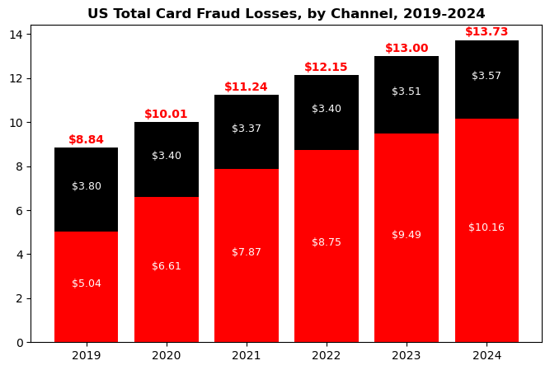
FIG 1.

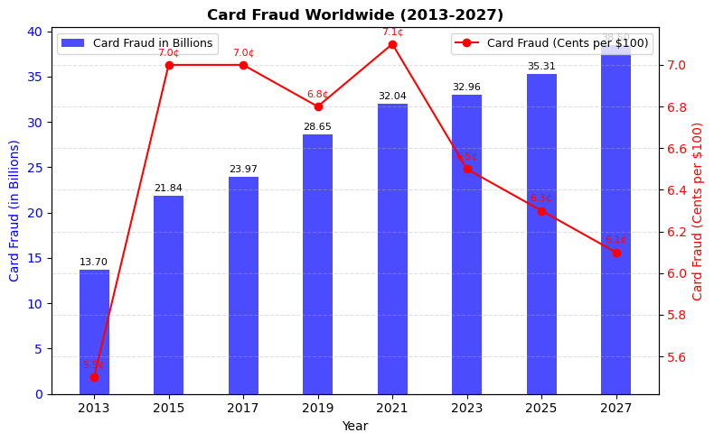
FIG 2. Increment of credit card frauds

LITERATURE REVIEW
Credit card fraud discovery has been considerably studied using colorful machine literacy( ML) ways. Bayesian and Neural Network models have demonstrated effectiveness, with Bayesian models noted for their faster calculation pets( Zareapoor et al., 2012). Logistic Retrogression, stressed by Alenzi and Aljehane( 2020), achieved a delicacy of 97.2, while Jain et al.( 2019) reported a 97.15 delicacy for K- Nearest Neighbors( KNN). Advanced styles similar as Random Forest( RF) and Support Vector Machines( SVMs) have also shown promising results, with SVMs achieving nearly 99 delicacies( Varmedja et al., 2019). mongrel approaches, similar as combining RF with insulation timber or using XGBoost, further enhance discovery delicacy but may introduce sequestration enterprises.
Random Forest has constantly been linked as a largely effective algorithm for fraud discovery, particularly for large and imbalanced datasets. Studies by AbdulKareem and Abdulazeez( 2021) demonstrate its capability to reduce overfitting through aggregation of multiple decision tree prognostications. SVMs and KNN are effective for lower datasets, with KNN being noted for its simplicity and effectiveness in anomaly discovery despite being memory- ferocious( Awoyemi et al., 2017; Sahin & Duman, 2011). Artificial Neural Networks( ANNs), with their fault forbearance and rigidity, have shown pledge in handling large datasets but bear careful configuration. While SVMs exceed for lower datasets, they face challenges in scalability. Arising mongrel styles combining machine literacy with network ways or data mining approaches, similar as those explored by Wen- Fang Yu and Na Wang( 2020), demonstrate effectiveness in relating unusual deals and enhancing vaticination delicacy.
Fraud detection research has evolved from traditional statistical models to dynamic algorithms like ML and deep learning. Data mining techniques, as studied by Phua et al. (2009), and outlier detection methods, have played a crucial role in improving fraud detection capabilities. Data analytics is pivotal in processing large-scale datasets, enabling real-time fraud assessment, and ensuring better fraud detection accuracy Patel, K., n.d (2023).

METHODOLOGY
Dataset Description
This dataset includes credit card transactions conducted by European cardholders in 2023. It contains over 550,000 entries, with all personal information anonymized to safeguard the identities of the cardholders. The primary purpose of this dataset is to aid in the creation and testing of fraud detection models and algorithms to identify suspicious transactions.
Key Attributes:
id: A unique identifier assigned to each transaction.
V1–V28: Confidential features that represent various transaction characteristics (e.g., time, location, etc.).
Amount: The monetary value of the transaction.
Class: A binary indicator specifying whether a transaction is fraudulent (1) or legitimate (0).
Data preprocessing
In the preprocessing stage of data, some necessary steps were taken in preparation for training the machine learning model. First, irrelevant columns, such as 'class' identifiers, were removed from the dataset to eliminate features that are not contributing to the learning process. This simplifies the data, making the model more efficient and ensuring that only relevant attributes are considered. The dataset was carefully screened for missing values, and nothing was found missing: this ensured that no lapses occurred in the dataset. The dataset was divided into training and testing sets, as follows: 80% for training, and the remaining 20% for testing, aiming to ease the training and evaluation processes. Further, the numerical feature "amount" was examined thoroughly for outliers since extreme values may dramatically affect the prediction of the model and result in a poor outcome. Hence, with these preprocessing steps, the dataset is made suitable to machine learning that improves model accuracy and generalization.

MODEL CONSTRUCTION

RANDOM FOREST- Credit card fraud detection leverages the Random Forest algorithm, implemented via Scikit-learn, to identify patterns and relationships within large datasets. As an ensemble learning technique, it combines multiple decision trees to enhance predictive accuracy while reducing overfitting. Key parameters, such as the number of trees, maximum depth, and minimum samples per leaf, were fine-tuned through hyperparameter optimization to balance model complexity and generalization. The dataset is binary, categorizing transactions as either fraudulent or genuine, and the model was tailored to address these two classes. Scikit-learn’s features simplified the integration and evaluation of the algorithm within the machine learning pipeline. The model's effectiveness was assessed using precision, recall, accuracy, F1 score, and the confusion matrix, ensuring a balanced approach to identifying fraud while managing false positives and false negatives

XGBOOST: XGBoost, or eXtreme Gradient Boosting, is a powerful machine learning algorithm for classification, regression, and ranking tasks. It improves upon Gradient Boosting by incorporating ensemble techniques like bagging and boosting. Bagging creates multiple bootstrap samples for training, while boosting sequentially trains weak learners, correcting errors to enhance performance. XGBoost stands out for its speed, parallel computing capabilities, handling of missing data, and built-in cross-validation. With fewer parameters to tune, it minimizes overfitting through regularization, making it highly effective for solving complex, real-world problems efficiently

SVM: Support Vector Machines (SVM) are effective for credit card fraud detection (CCFD), offering high accuracy with smaller datasets. However, their performance declines with larger datasets, limiting real-time applicability. Hybrid models combining SVM and Random Forest Classifier (RFC) improve fraud detection in high-dimensional, imbalanced datasets by enhancing accuracy (95%) and sensitivity (87%) while reducing false positives. Despite their success, these models face challenges with transaction privacy and scalability. Federated learning combined with artificial neural networks has been proposed to address these issues, ensuring privacy preservation and better handling of large datasets.

CROSS VALIDATION: Repeated Stratified K-Fold Cross-Validation was employed to ensure a robust and unbiased evaluation of the Random Forest model's performance in credit card fraud detection. This approach uses 5 splits and 20 repetitions, preserving class distribution across each fold to prevent skewed representations. In each iteration, the model is trained on four folds and validated on the fifth, with this process repeated across all splits and cycles. By repeating the stratified cross-validation multiple times, this method provides a more reliable estimation of the model's generalization ability, ensuring consistent performance across various data subsets. This strategy enhances the robustness and trustworthiness of the evaluation process, making the methodology more reliable for detecting fraudulent transactions.

EVALUATION METRICS

Five performance metrics were shown in this research paper to help us understand the models better and to select the best model for deployment.

Recall
Recall, also known as sensitivity or the true positive rate, is a crucial metric in credit card fraud detection. It calculates the proportion of actual fraudulent transactions that are correctly identified by the model. High recall is vital to minimize false negatives, ensuring that fraudulent activities are detected and not overlooked. In fraud detection, where undetected fraud can have severe consequences, maximizing recall is essential.

Precision
Precision refers to the ratio of correctly predicted fraudulent transactions to the total predicted as fraudulent. It measures the model's accuracy in classifying transactions as fraud. Achieving high precision is important to avoid false positives, where legitimate transactions are mistakenly flagged as fraudulent. Balancing precision and recall is key to building an effective fraud detection system that minimizes both false positives and false negatives.

Accuracy
Accuracy measures the overall proportion of correct predictions (both fraudulent and non-fraudulent) out of all predictions made. While commonly used, accuracy can be misleading in imbalanced datasets, such as those in fraud detection, where fraudulent transactions are rare. Relying solely on accuracy might not provide a complete view of the model's effectiveness, making it essential to consider other metrics alongside it.

F1 Score
The F1 score, the harmonic mean of precision and recall, is a valuable metric for credit card fraud detection.It provides a balanced evaluation by considering both false cons and false negatives. The F1 score is particularly useful when seeking a trade-off between precision and recall, ensuring that the model detects fraudulent transactions without unduly flagging legitimate ones.

Confusion Matrix
The confusion matrix is a powerful tool for assessing a model’s performance in fraud detection. It breaks down predictions into true positives, true negatives, false positives, and false negatives, offering a detailed view of the model's strengths and weaknesses. Analyzing the confusion matrix allows for further optimization by revealing the types of errors the model is making, leading to better adjustments and improvements.

RESULTS
Model Performance Comparison
The analysis tells that the XGBoost model has achieved the highest accuracy (90.00%), owing to its ability to effectively balance computational efficiency with advanced regularization techniques. Followed closely by Random Forest (88.62%) , showcasing its robustness through ensemble learning, which mitigates overfitting and captures intricate data relationships. SVM (86.50%), SVM, while effective for smaller datasets, achieved an accuracy of 97.5% but struggled with scalability when applied to larger datasets, making it less suitable for real-time fraud detection scenarios.
Benefiting from its simplicity and effectiveness in identifying anomalies based on proximity measures, although its computational intensity for large datasets posed challenges.

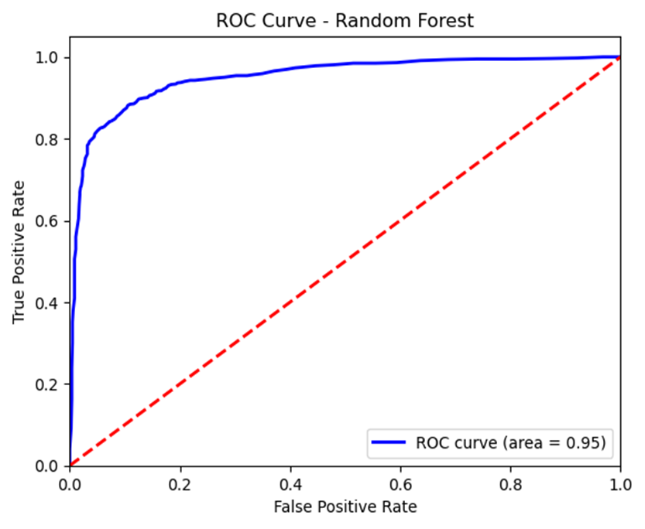

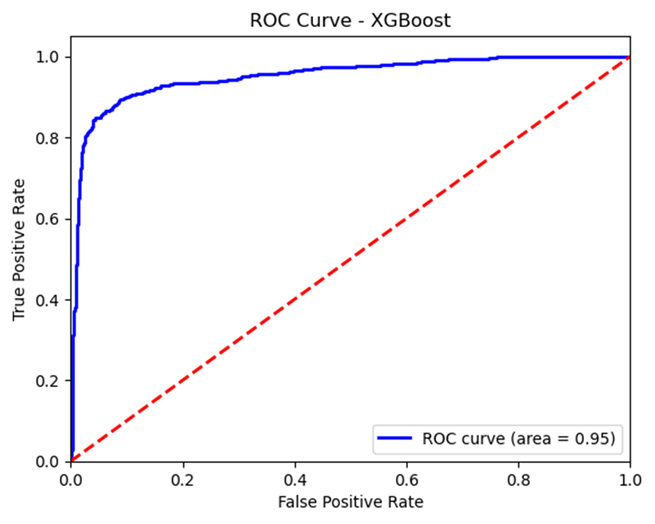

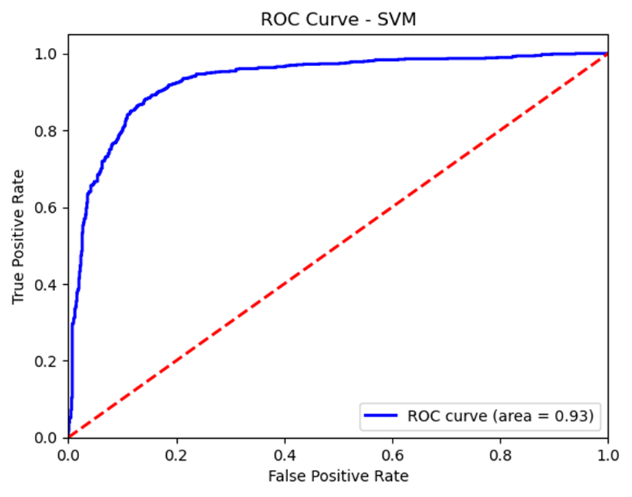

Evaluation Metrics:
Formulas for Evaluation Metrics:
True Positive Rate (TPR or Recall) = TP/TP+FN
False Positive Rate (FPR) = FP/FP+TN
Obtain Recall(TPR): It can directly be find out from the TPR values on the Y-axis of the ROC curve.

Precision = TP/TP+FP

F1 Score:
F1 = 2 ( Precision*Recall/ Precision + Recall)

Confusion Matrix:
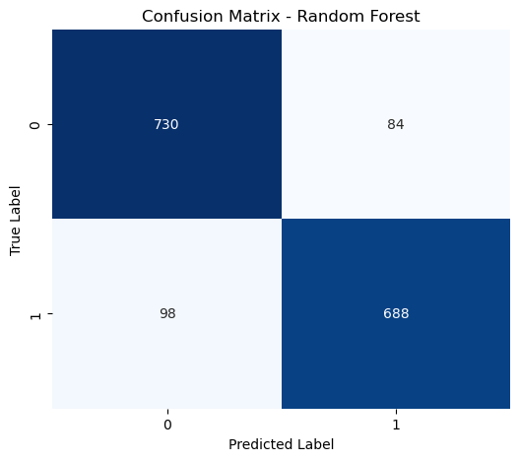

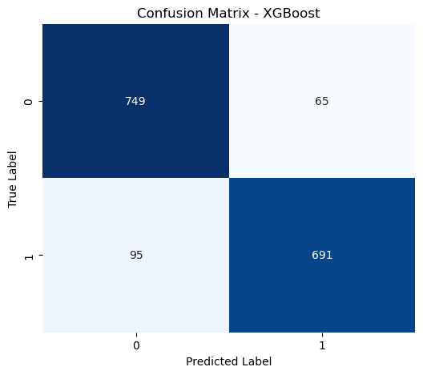
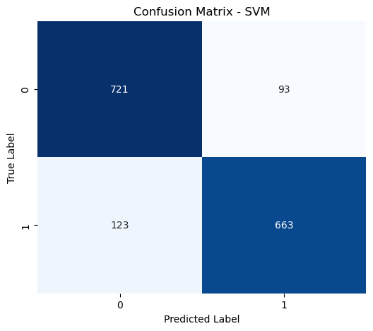

Cross Validation: The 80-20 Training to Testing Split. This approach uses 5 splits and 20 repetitions, preserving class distribution across each fold to prevent skewed representations.

Conclusion

This study compares the performance of three widely-used algorithms—XGBoost, Random Forest (RF), Support Vector Machine (SVM),—in detecting fraudulent transactions using a large dataset of 550,000 anonymized transactions from European cardholders in 2023. The dataset preprocessing, including removal of irrelevant features, handling of outliers, and the creation of training and testing sets. The evaluation of model performance utilized key metrics such as precision, recall, accuracy, F1 score, and confusion matrix to provide a comprehensive understanding of each model’s strengths and weaknesses.K-Fold Cross-Validation was employed to ensure a robust and unbiased evaluation of the Random Forest model's performance in credit card fraud detection. This approach uses 5 splits and 20 repetitions, preserving class distribution across each fold to prevent skewed representations. The results showed that XGBoost outperformed other models with the highest accuracy of 90.00%, benefiting from its advanced regularization and computational efficiency. Random Forest followed with an accuracy of 88.62%, demonstrating its robustness through ensemble learning. SVM achieved 86.50% accuracy but faced scalability issues with larger datasets. Overall, XGBoost provided the most reliable and scalable solution for fraud detection, emphasizing the importance of selecting models that balance accuracy, scalability, and computational efficiency in real-world applications.

References

- Kaushikkumar Patel, “Credit Card Analytics: A Review of Fraud Detection and Risk Assessment TechniquesA”, International Journal of Biotech Trends and Technology · October 2023

- Vaman A. Saeed1, Adnan M. Abdulazeez2 ,Credit Card Fraud Detection using KNN, Random Forest and Logistic Regression Algorithms : A Comparative Analysis

- Rejwan Bin Sulaiman1 · Vitaly Schetinin1· Paul Sant1, “Review of Machine Learning Approach on Credit Card Fraud Detection”: Human-Centric Intelligent Systems. May 2022

- Wen-Fang YU and Na Wang , Research on Credit Card Fraud Detection ,International Joint Conference on Artificial Intelligence 2009

- Meera AlEmad, “Credit Card Fraud Detection Using Machine Learning” : Rochester Institute of Technology. July 2022

- Pushpita Chatterjee,“Securing Financial Transactions:Exploring the Role of Federated Learning and Blockchain in Credit Card Fraud Detection”

US Card Payment Fraud Losses Forecast 2022 Rising Card-Not-Present Fraud Hits Merchants, Issuers, and Consumers, https://www.emarketer.com/content/spotlight-us-card-payment-fraud-losses-forecast-2022
- Mayowa Timothy Adesina and Luke Howe “Credit Card Fraud Detection” , 2024
K.K. Mohbey. Mohammad Zubair Khan. Ajay Indian “ Credit-Card-Fraud-Prediction-Using-XGBoost-An-Ensemble-Learning-Approach”, (July 2022)

- Rejwan Bin Sulaiman · Vitaly Schetinin · Paul Sant “Review of Machine Learning Approach on Credit Card Fraud Detection” , 2022

